MoPub and Unity Ads project by Andrés Castro

Introduction

Hi everyone

This project contains de answers for the Part 1 of the Technical Home Assessment from Unity Technologies using the 2020.2.0b8 Unity´s version.

The Folders contains:

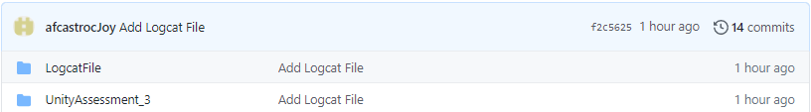

Where LogcatFile contains the logs generated by device when app is open and active also UnityAssessment_3 contains the Unity project.

The Unity project structure is:

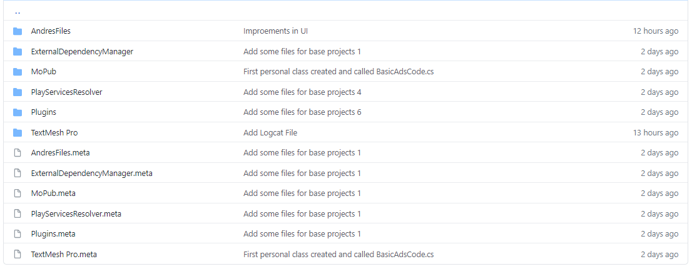

Where the AndresFiles contains all files generated for solve the assessment, ExternalDependencyManager contains the editor resources. Mopub contains the core files for use the SDK. PlayServicesResolver contains the AndroidSolver tool provided by MopubSDK plugin. Plugins contains the library files needed that MoPub SDK and Unity Ads require generated by Android Resolver and TextMeshPro contains the files used in the UI Unity system.

The AndresFiles contains:

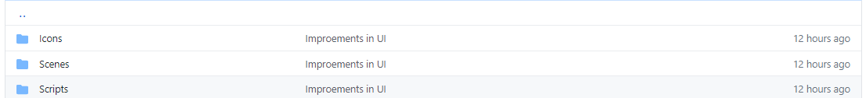

Where Icons folder contains images used in the application. Scenes folder contain the scene file created for complete the assessment and Scripts folder contain the files writed by solve the assessment requirements.

The Scripts Folder contains:

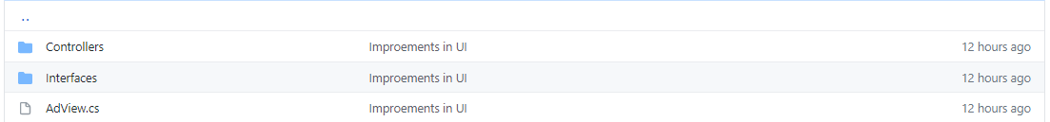

The AdView is the main script, Is a facade, get the inputs from UI Buttons and connect with controller files. If you open the UnityAssessment scene you can find them in “AdsController” object.

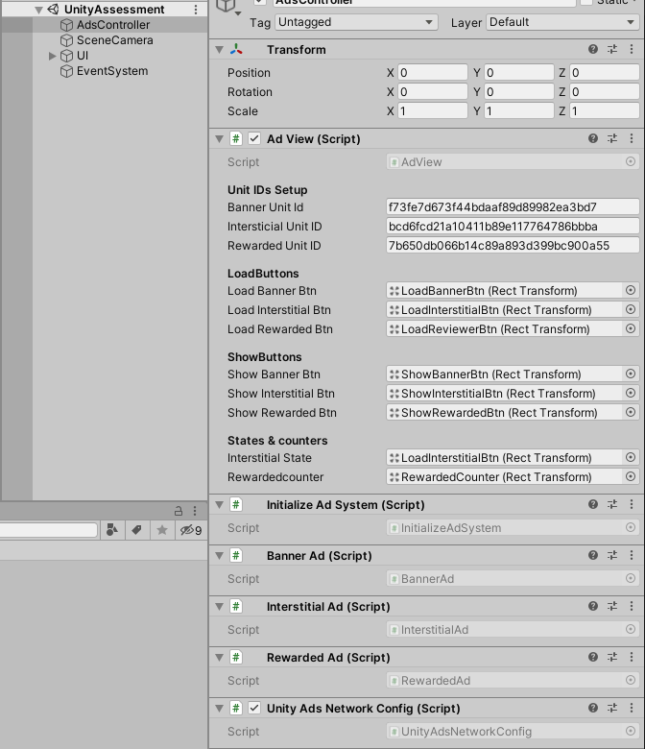

Controllers Folder contains the scripts that handler the load and show ads with their events process.

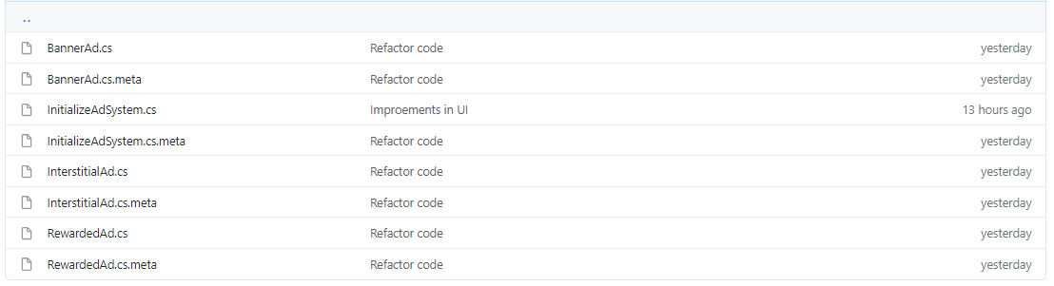

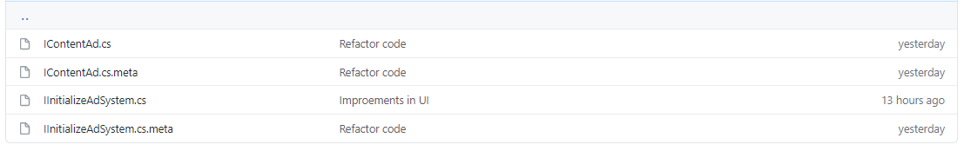Interfaces Folder contains the interface files required by controllers

Logcat File

The logcat file provided has been taked from AndroidStudio and shows the logs generated by unity application, the crash show at end of file is because the interstitials never loaded even in the scene provided by SDK and you can find it in the Mopub directory - Sample.

I searched in different forums and webpages but i could not find any information about solve this error I writed to support (support@mopub.com) but i dont received response.



The Apk generated you can find in the Root of the repository

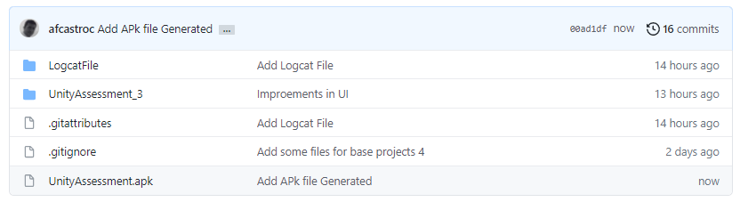

Understanding Project

For understand the project you can clone or download the unity project, remember that unity version used in this case was 2020.2.0b8, Mopub version: 5.16.3 and Unity Ads adapter version: 1.3.4

Open the project with Unity and open the AndresFiles folder, open it and open the Scenes folder, open the scene called “UnityAssessment”

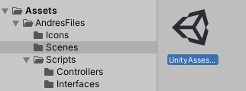

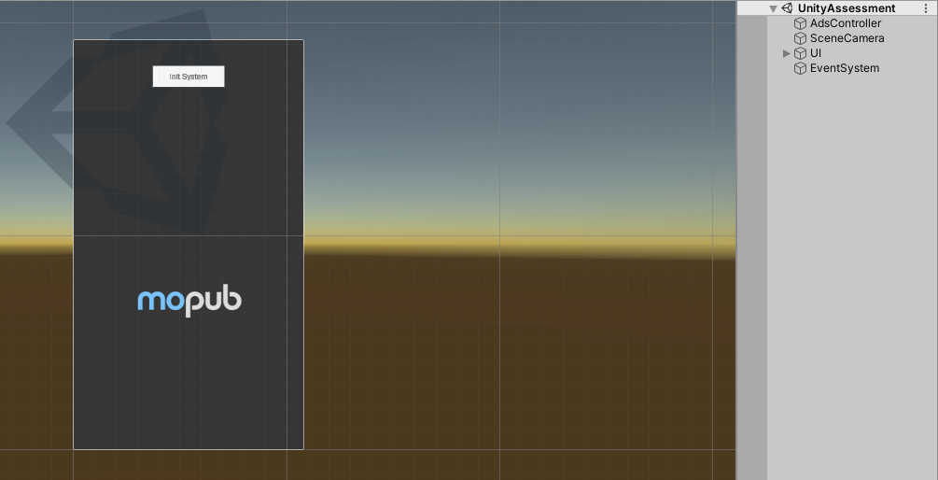You can see the scene

The Main script is “AdView” and you can find it at “AdsController” game object.

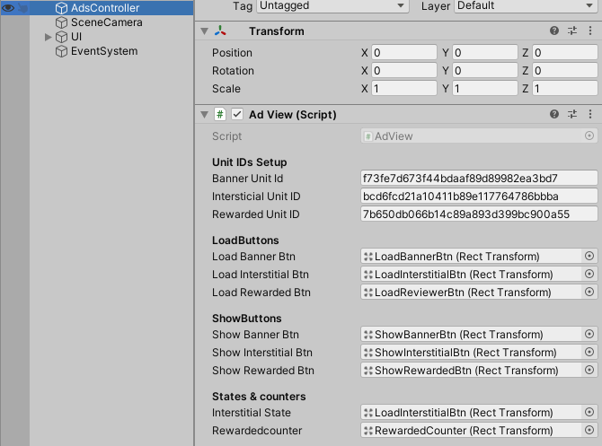

The script is Monobehavior and contains the UnitIDs required by MoPub for load and request the differents ad types, in this case, Banner, Interstital and Rewarded Videos. Also contains the different UI Objects that will be used by the system to hide or show options.

ADVIEW SCRIPT

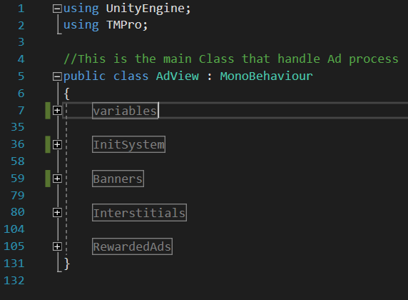This script is the start point. You can find in it the variables, Init functions and Ads functions.

INIT SYSTEM

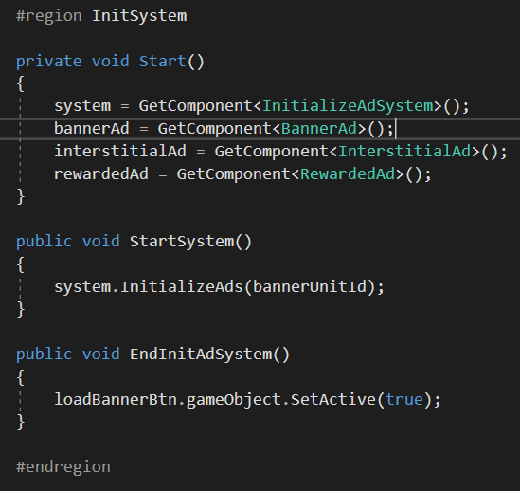 This point work in get the components required by system and call the InitializeAds to load plugin, while EndInitAdSystem show the load Banner option in UI when the plugins was loaded.

BANNERS

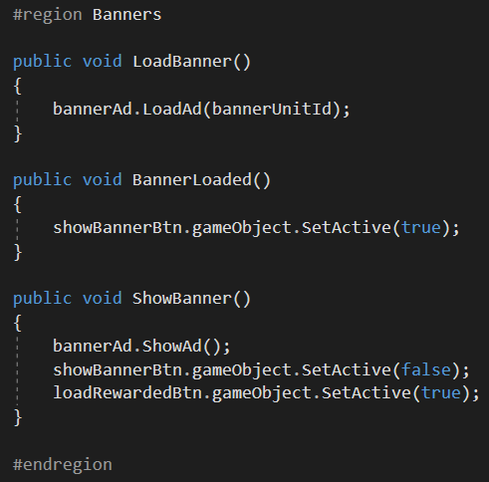This part contains the methods for load, active the “Show Banner” option in UI when the banner was loaded and show the banner when the option is pressed by user.

ITERSTITIALS

Is similar to Banner system, contains the methods for load, show UI option for visualize the ad and change the interstitial state.

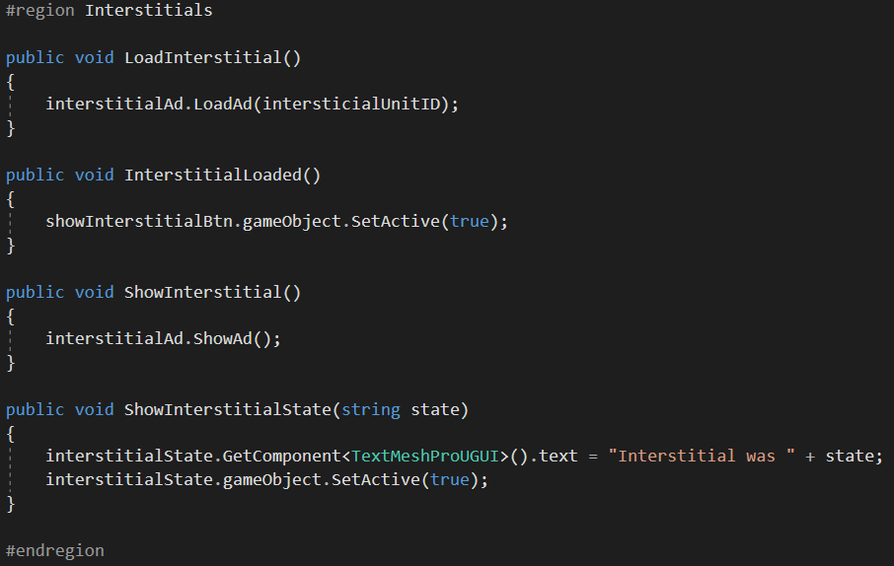

REWARDED VIDEOS

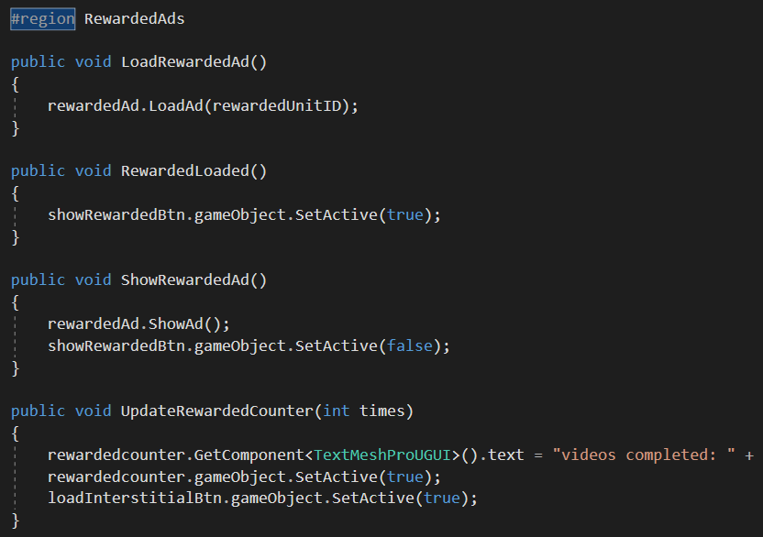Working same, contains the methods to Load, handle the UI buttons state and Show the ads with the counter.

CONTROLLERS

The controllers load ad system, load the Ad plugins, make the request and show the Ad using or implement an interface that contains the enough methods for all kind of Ads.

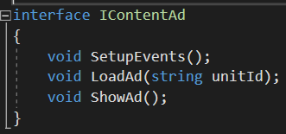Interface

Also, the controller has the events to detect if Ad was loaded, Showned, Skipped, Finish, etc. and generate actions like the counter in the Rewarded video ad or the state of interstital ad.